Abstract—Electrocardiograms (ECG) provide an effective, non-invasive approach for clinical diagnosis and monitoring treatment in patients with cardiac diseases including the most common cardiac arrhythmia, atrial fibrillation (AF). Portable ECG recording devices including Apple Watch and Kardia devices have been developed for AF detection. However, the efficacy of these smart devices has not been fully validated and remains elusive. We aimed to develop an open-source deep learning framework for automatic AF detection using the largest publicly available single-lead ECG dataset through a mobile Kardia device enhanced with style transfer-driven data augmentation. We developed and validated a 37-layer convolutional recurrent network (CRN) using 5,834 single-lead ECGs with a mean length of 30 seconds from the 2017 PhysioNet Challenge to automatically detect sinus rhythm and AF. To address the challenge of a lack of AF samples, we proposed a novel style transfer generator that fuses patient-specific clinical ECGs and mathematically modelled ECG features to synthesize realistic ECGs by five-fold. The differences between synthesized and clinical ECGs were analyzed by studying their average ECG morphologies and frequency distributions. Our results indicated the style transfer-driven data augmentation was not classifier-dependent. Validation on 2,917 clinical ECGs showed an F₁ score of 96.4%, with the generated ECGs contributing to a 3% improvement in AF detection. By developing and evaluating our approach on an open-source ECG dataset, we have demonstrated that our framework is both robust and verifiable, and potentially can be used to validate portable devices for AF classification.

Index Terms—Atrial Fibrillation, Data Synthesis, Convolutional Recurrent Networks, Neural Style Transfer

INTRODUCTION
Atrial fibrillation (AF) is the most common form of cardiac arrhythmia [1], and is associated with substantial morbidity and mortality [2, 3]. Electrocardiograms (ECG) is a widely used, non-invasive approach for the clinical diagnosis in patients with AF. However, normally diagnoses require specially trained health professionals to identify abnormal ECG waves and can often be a rather subjective process due to the complex nature of ECGs.
Automated classification of ECGs may therefore greatly aid clinical diagnosis when experts are not readily available. However, a robust and automated algorithm is lacking as traditional methods involving P-wave and R-peak-to-R-peak (RR) interval analyses have limited efficacy [4-7].
In recent years, many portable mobile devices have been developed capable of automatically monitoring the health state of patients, notably Apple Watch [8] (Apple Inc, California), KardiaBand/Mobile [9] (AliveCor Inc, California), Huawei Watch [10] (Huawei technologies Co. Ltd, Shenzhen), and Cardiio Rhythm [11] (Cardiio Inc, Massachusetts) by utilizing ECG signals recorded from handheld or wearable ECG monitors or through photoplethysmography (PPG). Although many studies have been conducted, the accuracy of current commercially available portable devices for AF detection remains unclear. Bumgarner et al. compared the accuracy of the KardiaBand for AF detection from self-recorded ECGs with physician-interpreted 12-lead ECG diagnoses in 100 patients [9] and concluded the KardiaBand was unable to interpret a third of the patient’s recordings while the physicians were able to accurately diagnose AF in 99% of patients. Moreover, a recently published study for the most widely used Apple Watch device on >400,000 patients showed AF was only present in 34% of the patients detected by the device when validated by a physician using a subsequent conventional ECG patch, showing the high propensity for false alerts [8].
The development and validation of automated methods for ECG classification in these smart devices remain difficult due to the lack of a large and well labelled ECG dataset. The issues surrounding the lack of data may potentially be mitigated with well-established data augmentation. However, existing augmentation techniques commonly applied to images such as rotation, flipping, or resizing are ineffective as ECGs are much more rigid in terms of its data structure. A method of artificially generating sufficient synthetic ECG samples is therefore ideal. Additionally, artificial intelligence algorithms, such as convolutional reccurent networks (CRN), have been applied to many challenging tasks in the field of medicine [12, 13] for signal processing.
In this study, we have designed a robust CRN using currently the largest open-source single-lead ECG dataset donated by AliveCor [14] for the automatic detection of AF (Fig. 1-2). We have incorporated different CRN layers to improve feature learning from raw ECG signals and an architecture that is capable of processing ECG recordings of variable length. To overcome the issue of the limited data samples, we have proposed a novel generator capable of synthesizing a large number of realistic ECG recordings from current samples of clinical ECGs. This leads to a multi-fold increase in the number of training data available and significantly improves AF detection accuracy of the CRN. By developing our method on an open-source dataset, our research is therefore reproducible.

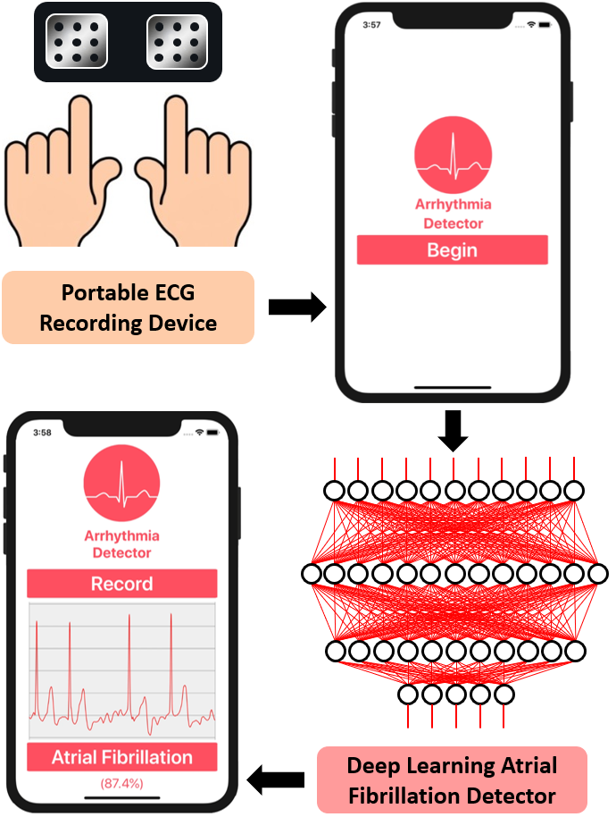
Fig. 1. Outline of the proposed pipeline containing portable recording electrodes and a mobile application embedded with a deep learning algorithm for the detection of atrial fibrillation (AF) from single-lead electrocardiograms (ECG).

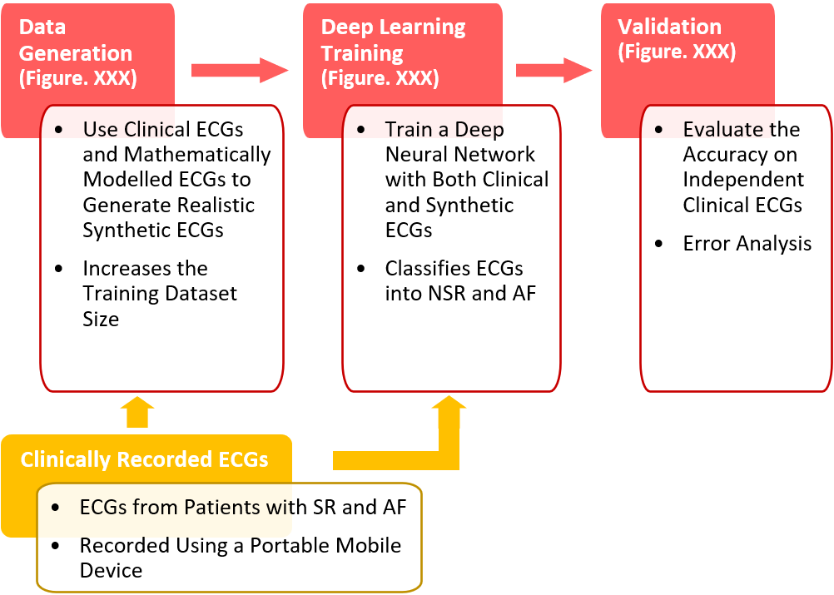
Fig. 2. Workflow for the development of a superior deep learning algorithm trained on both clinical and synthetic electrocardiograms (ECG) to detect atrial fibrillation (AF). NSR, non-sinus rhythm; SR, sinus rhythm.

Methods

Clinical ECG Dataset
The dataset used in this study was from the 2017 PhysioNet/Computing in Cardiology Challenge, donated by AliveCor, which contained 5,834 single-lead ECG recordings recorded from patients with a self-diagnosis device [14]. The device contained two electrodes which were held in each hand to create a lead I equivalent ECG. The signals were recorded for an average length of 30 seconds, with the shortest recording being 9 seconds and the longest recording being 60 seconds in length. The frequency of the signal was 300 Hz with a dynamic range of ± 5 mV. Expert annotations were provided by AliveCor and validated by the 2017 PhysioNet challenge organizers [14] and contained the labels of sinus rhythm (SR) and AF.
Overall, the dataset contained 5,076 SR recordings and 758 AF recordings. The dataset was split into 50% training and 50% testing such that the developed methods could be validated on an independent dataset.

Synthetic ECG Generation
The A novel method for synthesizing ECGs was developed to provide a deep learning algorithm with more training samples for AF detection. The ECG generator consisted of three components: 1) clinical ECG recordings as described above, 2) a mathematical model consisting of a system of ordinary differential equations [15], and 3) a convolutional neural style transfer network [16] (Fig. 3).
The mathematical model was first used to model idealized ECG waves with a specific heart rate, or pacing of the RR intervals, via parameters for the mean and standard deviation of the heart rate (Fig. 3B). The algorithm used for the modelling of ECG beats consisted of a system of ordinary differential equations (ODEs). The variables controlling the morphology of each ECG beat cycle were initialized and controlled by the amplitude, a_{i}, the angular spread, b_{i}, and the locations of the Gaussian functions, θ_{i}. These three variables were arrays consisting of 7 values each, corresponding to the 7 components of a simplified ECG: P⁻, P⁺, Q, R, S, T⁻, T⁺. The minus represented the first half of a wave while the plus represented the second half of a wave. By adjusting the values in the 3 arrays, varying morphologies of ECG signals could be reproduced consistently with high precisions.
The simulation was performed with 3 ODEs (P, QRS, T), each of which determined the morphology of the P-wave, QRS complex, and T-wave respectively. The final ECG sample was then the sum of the final solutions of the three ODEs across a pre-defined space determining the length of the ECG signal. The equations were as follows for the three variables with respect to the number of iterations, k and max iteration, K, in a discrete form

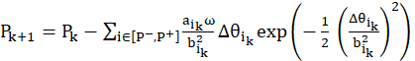 (1)
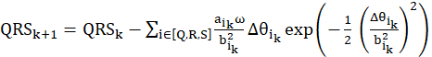 (2)
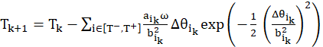 (3)

where a_{i}, b_{i} and θ_{i} each contained the components [P⁻, P⁺, Q, R, S, T⁻, T⁺] and P₀ = 0, QRS₀ = 15, T₀ = 0. ω was defined as 2πf for a pre-defined heart rate frequency and Δθ_{ik} is the difference between the current θ_{ik} and the phase of the signal modulus 2π. The final output is thus P_{K} + QRS_{K} + T_{K}.
The convolutional neural style transfer network used to generate synthetic ECGs utilized a simple 1-layer 1D network with 128 feature maps to process features from the real clinical data and the mathematically modelled data to produce an output containing features from both data samples (Fig. 3C). The aim of the network was to combine the heart rate features from the simulated data, referred to as the content, with the patient-specific P-QRS-T features in the clinical data, referred to as the style (Fig. 3D).

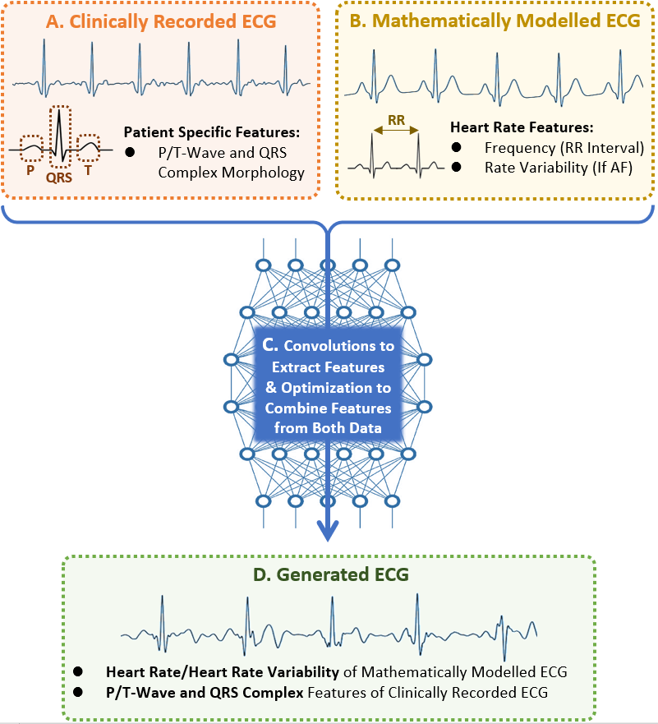
Fig. 3. Method for generating realistic electrocardiograms (ECG) to increase the data available for deep learning. A) Clinically recorded ECGs containing patient-specific P-QRS-T features. B) Heart rate features from mathematically modelled ECGs. C) The combination of patient-specific P-QRS-T features of clinical ECGs and heart rate features of mathematically modelled ECGs with a convolutional feature extractor and optimizer. D) The generated output consisting of a realistic synthetic ECG. AF, atrial fibrillation; RR, R-peak-to-R-peak.

To produce realistic ECG signals effectively, the features were initially extracted and compared from both the content and style. The content features were the convolutional activations outputted from the 1D convolutional layer and the style features were the inner product of the vectorized convolutional activations outputted. For each pair of content and style ECGs, the generation process began by initializing the output signal with random values. The content features from the content signal and the output were compared, and the style features from the style signal and the output were compared to compute their differences. The values within the output signal were then optimized such that both its content and style features converge towards those of the content and style signal [17], producing a realistic simulated ECG signal as a result. This was achieved by minimizing a loss function for each of the content and style features. In our network, the content loss, L_{c}, was defined by

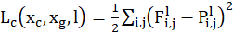 (4)

given the content signal, x_{c}, generated signal, x_{g}, at layer l = 1 of our simple network. In this equation, F and P represent the features extracted for the content and generated signals respectively. The style loss, L_{s}, was defined by

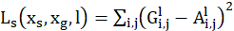 (5)

given the style signal, x_{s}, generated signal, x_{g}, at layer l = 1 of our simple network. G and A represent the inner product of the vectorized features extracted for the style and generated signals respectively. The overall loss was finally a weighted sum of L_{c} and L_{s} with equal weightings. Through this method, the ECG dataset used for deep learning could be increased multi-fold by using different pairs of clinical ECGs and mathematically modelled ECGs with different heart rate settings.

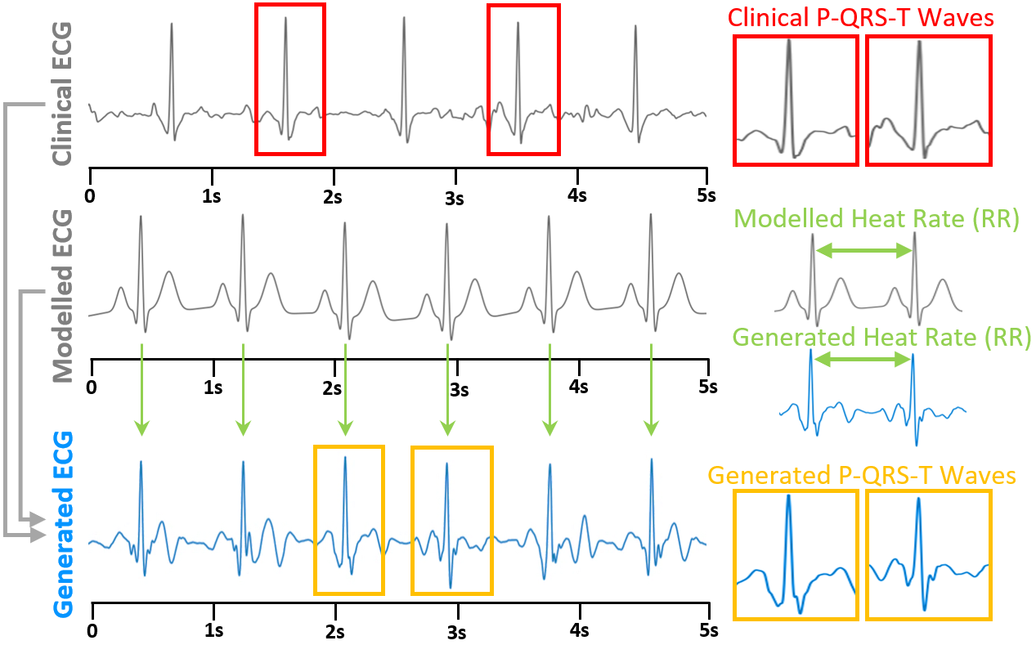
Fig. 4. Generation of realistic synthetic ECG data for sinus rhythm. The generated ECG (orange) displays the P-QRS-T waveform features of the clinical ECG (red) and the heart rate pattern of the mathematically modelled ECG (green).

The generation of SR and AF ECGs were conducted separately to capture the different P-QRS-T features present in different pathologies. Generation of SR signals was conducted with pairs of clinical SR ECGs and mathematically modelled ECGs with heart rates ranging from 50 beats per minute (bpm) to 120 bpm without any heart rate variability (Fig. 4). Generation of AF ECGs was performed with pairs of clinical AF ECGs and mathematically modelled ECGs with heart rates

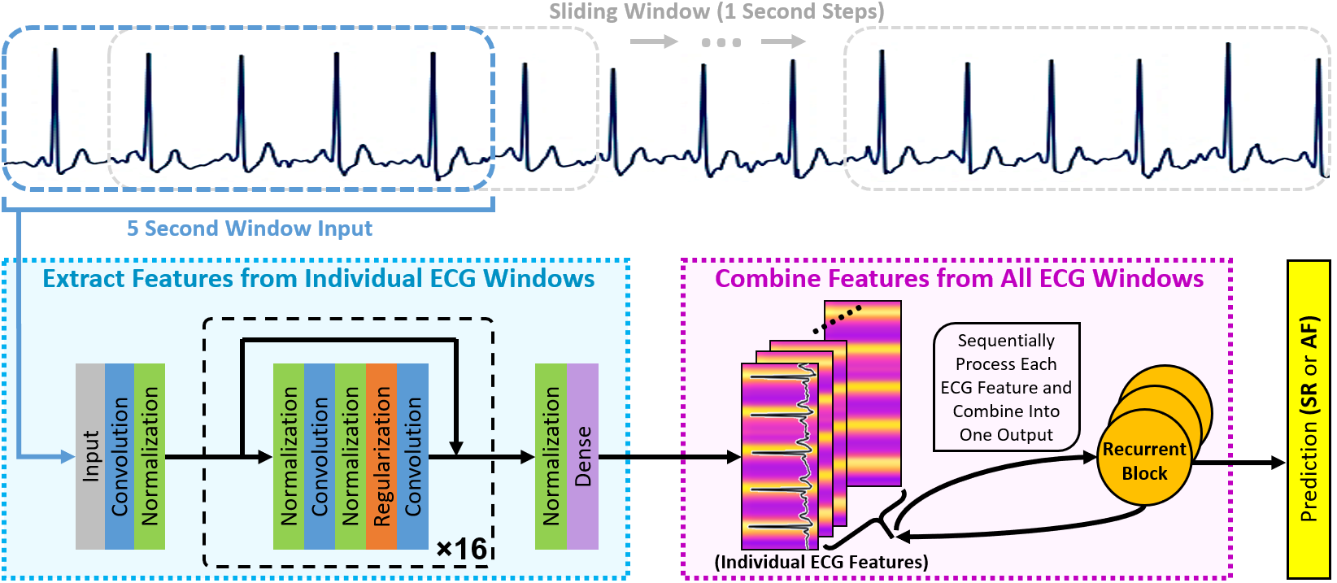
Fig. 6. Illustration of the convolutional recurrent network (CRN) used for classifying electrocardiograms (ECG). The ECG signal is processed with sliding windows of 5 seconds and then passed through a deep neural network consisting of convolutional layers. Individual features extracted from windows of 5 seconds are then sequentially combined with a recurrent block. The output from the recurrent layers is finally mapped onto a prediction of either normal sinus rhythm (SR) or atrial fibrillation (AF).

ranging from 60 bpm to 150 bpm and from a 0 to10 standard deviation to allow for varying heartbeat rhythms (Fig. 5). To minimize bias, all heart rates and heart rate variability values were sampled randomly based on the statistical distribution of the clinical ECG dataset used as the input to the generator.

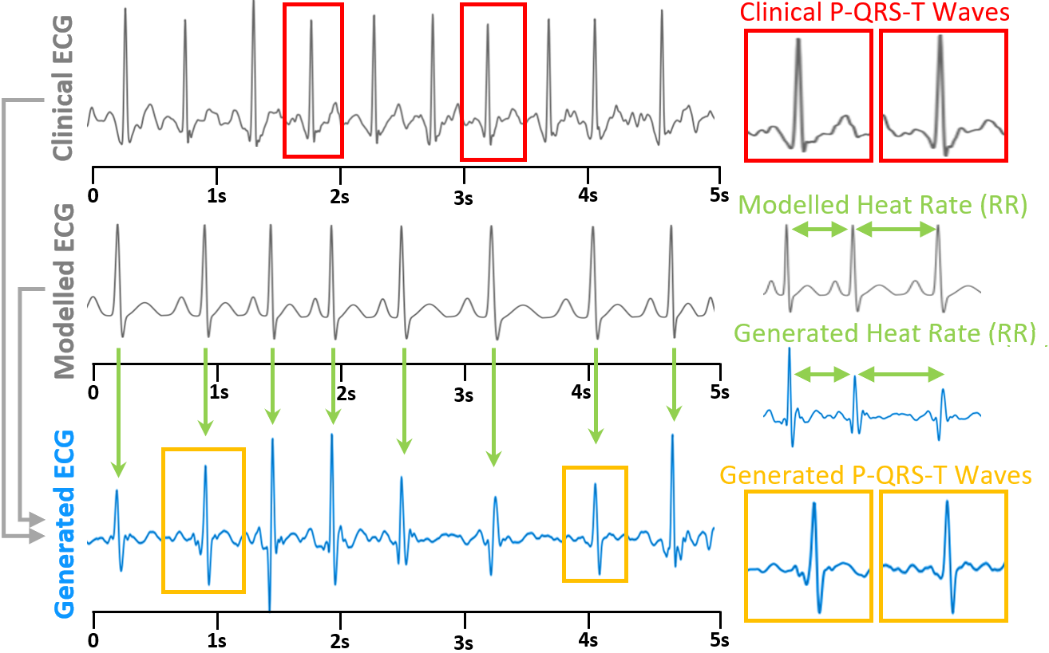
Fig. 5. Generation of realistic synthetic ECG data for atrial fibrillation. The generated ECG (orange) displays the P-QRS-T waveform features of the clinical ECG (red) and the heart rate pattern of the mathematically modelled ECG (green).

Atrial Fibrillation Detection Algorithm
A CRN was used for the detection of AF from raw 1D ECG waveforms [18, 19] (Fig. 6). Since the clinical ECGs were of different lengths, an overlapping sliding window approach was used in which a 5-second window was moved along the entire length of each ECG in 1-second steps to obtain localized information regarding the detailed P-QRS-T-wave morphologies. The features from each individual window were then collated with a recurrent block to analyze the temporal behavior of the ECG along the entire time-frame.
The architecture of the convolutional block consisted of 16 residual blocks [20]. In each residual block, the input was first normalized with batch-normalization [21] and a rectified linear unit [22], followed by a convolutional layer for feature extraction. The same normalization was then performed again followed by dropout for regularization [23], and finally another convolutional layer. The convolutional layers were one dimensional, contained a filter size of 16, and had 16 feature maps which doubled for every fourth convolution. Within each residual block, an additional side-connection without any operations was used to increase the efficiency optimization during training by allowing information to flow freely throughout the network in order to counteract the large number of convolutional layers. After the residual blocks, the output was then compressed into a dense feature map with a fully connected layer. This entire process was repeated for each 5-second ECG window. To collate the individual feature maps of all ECG windows along with the entire signal, 3 recurrent layers each with 512 feature maps [24] were used to sequentially process features maps at each time step. Lastly, the collated features were fed into a softmax activation to obtain the final output which was a prediction for either SR or AF.
The network was trained with the Adam optimizer [17] using the cross-entropy loss function. The framework was implemented with Tensorflow [25] on a Titan-V GPU (Nvidia Corporation, California), with each prediction taking approximately 0.1 seconds.
The CRN was validated on the independent testing set to determine the accuracies for the classification of SR and AF. The F₁ accuracy metric was used and was defined as the harmonic mean of precision and recall. Experiments were performed to determine the optimal number of synthetic ECGs to generate for training. Feature extraction and analysis were then performed to validate the realism of the synthesized data. Subsequent error analysis was conducted using a confusion matrix, and the incorrectly predicted signals in the testing set were extracted for further analysis.

Hyper-Parameter Selection
The proposed CRN contained several hyper-parameters which were carefully selected after extensive experimentation. Each hyper-parameter was tuned by keeping all other parameters of the network constant and evaluating the effects of incrementally adjusting the value with 5-fold cross validation on the training set. For each hyper-parameter, the value which resulted in the best cross validation F₁ score was selected for the final model.
Initially, the CRN was tested with 8, 16 or 32 residual blocks, each with 2 convolutional layers, followed by the use of 2, 3 or 4 recurrent layers. It was observed that as the number of residual blocks were increased from 8 to 16, there was a gradual increase in improvement. However, any subsequent increase in the number of residual blocks from 16 to 32 showed a clear trend in decreasing performance, potentially due to substantial overfitting as a result of the excess number of convolutional layers in the network. Furthermore, the same experiment testing the number of recurrent layers to use also produced a similar trend, where the performance improved from 1 to 3 recurrent layers, but decreased as the number of layers were increased from 3 to 6. In the end, 16 residual blocks, or 33 convolutional layers, and 3 recurrent layers were found to contain sufficient parameters to learn the complex features in the ECG signals and perform accurate ECG classification.
The number of parameters in each layer was further tuned to investigate the optimal number of parameters to use in the network by adjusting the filter size of the convolutional layers and the number of feature maps in the recurrent layers. The filter size in each convolutional layer was tuned by testing the entire network with 3 × 1, 5 × 1, 10 × 1 and 15 × 1 sized filter. Filters sized larger than this value was not tested due to the high computational costs which slowed down training and prediction run-time. Experiments testing the filter sizes showed that for 1D input, larger filters were more effective due to the increased receptive field being able to more effectively account for the variations of the signal over time. Adjusting the number of nodes of the recurrent layer did not result in any significant change as the majority of the processing was done by the residual blocks. Nevertheless, 512 proved to deliver a decent balance between learning capacity and avoiding over-fitting.

Results

Synthetic ECG Data
The synthetic ECGs showed that the generator framework was successful in reproducing important features present in real ECG recordings. The generated SR ECGs maintained well-defined P-waves with the RR distances being consistent throughout the signal (Fig. 4). The generated AF ECGs, on the other hand, contained F-waves or a lack of P-waves, and varying RR distances resembling real cases of ECGs obtained from patients with AF (Fig. 5).
The size of the ECG dataset available for training was increased five-fold by generating a sample of synthetic ECGs 400% the size of the training set. This resulted in a total of 11,668 new ECGs available for training including 10,136 SR samples and 1,532 AF samples.

Validation of Synthetic ECG
To compare the synthesized ECGs against the clinically recorded ECGs, we performed feature extraction on the signals. We extracted the individual P-QRS-T cycles for each heartbeat and overlaid the waveforms for both sets of signals (Fig. 7). The clinically recorded ECGs had a smaller variation between beats as the P-QRS-T cycles coincided with each other fairly closely without much variation in the amplitude. However, there was a much larger variation for the synthetized ECGs as seen by the larger discrepancies in the amplitude as well as the temporal positioning of the P and T waves between different beats. We discovered that synthesized ECGs contained significantly higher standard deviations for SR and AF (Fig. 8). The mean squared error (MSE) was then utilized to measure the average difference between synthetic ECG and its original clinical ECG (Fig. 9). As expected, although there was a difference in signal amplitudes, MSE decreased gradually as more clinical ECGs were used for the data generation process. Our frequency analysis showed that the synthetic ECGs contained a similar frequency distribution compared to the clinically recorded ECGs, demonstrating that the generator framework was able to effectively capture frequency features in the dataset (Fig. 10).

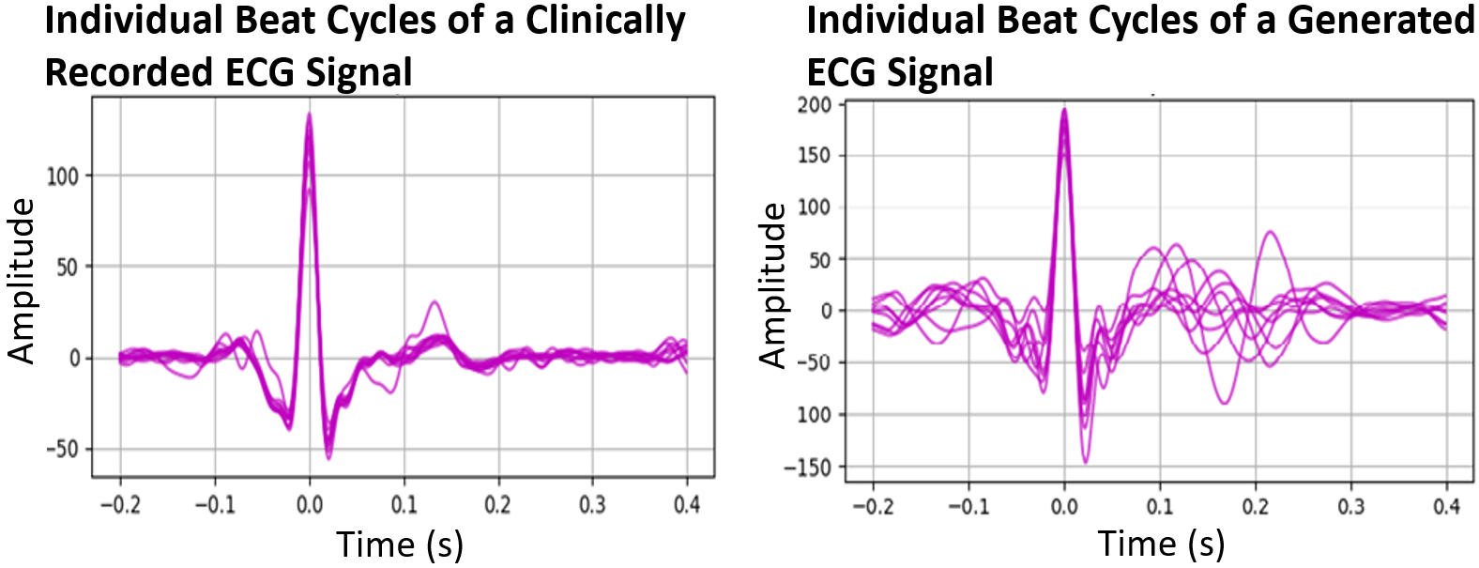
Fig. 7. Overlay of individual ECG P-QRS-T wave cycles extracted from each beat in clinically recorded (top) and synthetic (bottom) ECGs.
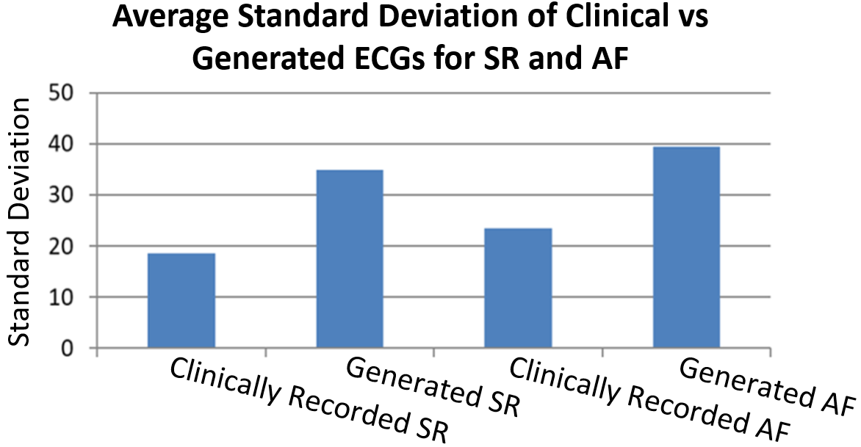
Fig. 8. The average standard deviation of clinically recorded and synthetic ECGs for sinus rhythm (SR) and atrial fibrillation (AF) signals.

The generalizability of the data generated was validated further through several experiments to demonstrate the accuracy and effectiveness of the ECG generator in capturing and reproducing features in the original clinical ECG dataset. Our augmentation strategy resulted in a superior performance regardless of the architecture or method used. Comparisons of the accuracy of our CRN with different numbers of convolutional layers ranging from 9 to 33 also showed that the augmentation approach improved the classification accuracy regardless of the configuration used Supplemental Table S1). Finally, we trained our CRN with only synthetic data and the results were an accuracy of 93.5% compared to 94.8% using a CRN trained on only real clinical data. This indicated that although there was a decrease in accuracy, overall, the generated data contained sufficient features to train the network effectively even when no real ECG samples were present (Fig. 11B).

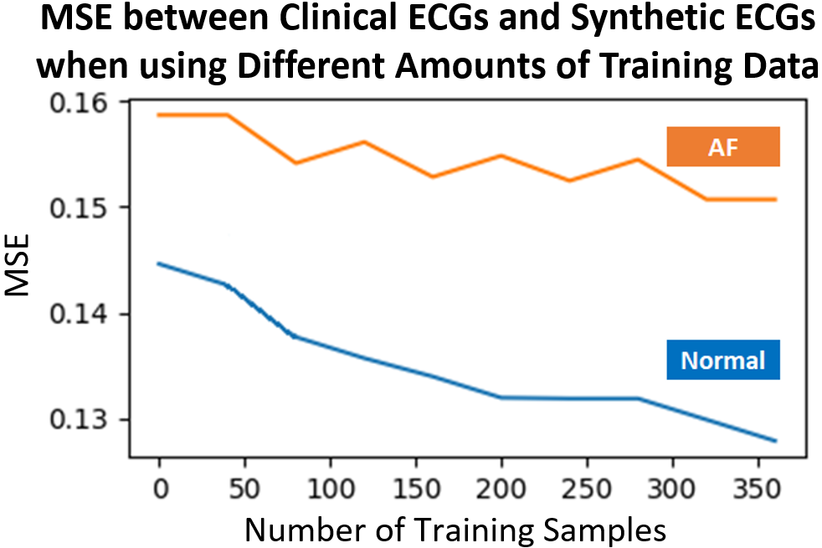
Fig. 9. The mean squared error (MSE) between the clinically recorded and synthetic ECGs plotted against increasing the number of clinically recorded ECGs used.

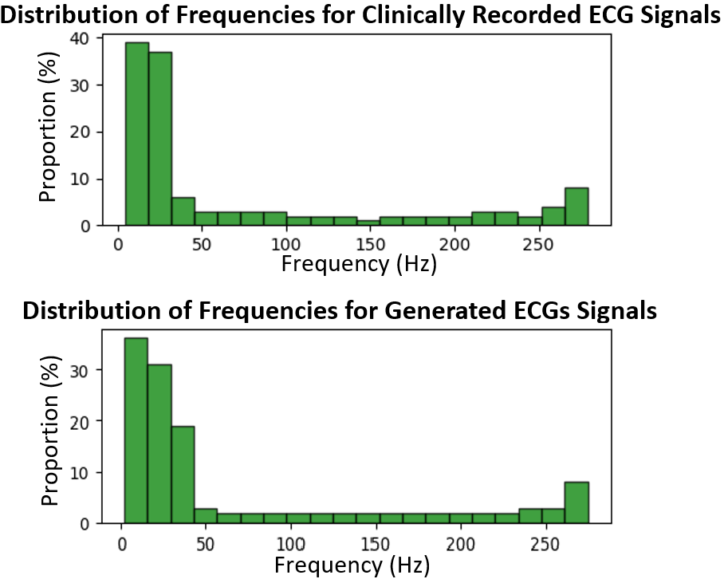
Fig. 10. Comparisons of the averaged frequency distributions obtained from the clinically recorded and generated ECG signals.

Atrial Fibrillation Detection Results
The proposed CRN achieved an overall F₁ score of 96.4% on the independent testing dataset, with 99.1% for SR and 93.8% for AF. Training experiments showed that this was obtained when the size of the synthetic ECG sample used was 300% that of the real clinical ECG dataset, creating a 1.6% improvement in the F₁ score and 3% improvement in AF detection compared without using any synthetic data for training (Table. I). Results also showed that there was a steady improvement as the amount of synthetic ECG data used for training was incrementally increased from 0% to 300% of the clinical dataset and the subsequent increase from 300% to 400% resulted in a declining accuracy.

TABLE I
The Accuracy Obtained when Different Amounts of Generated Electrocardiograms (ECGs) are used for Training Compared to the Currently Available Clinical ECG Training Set
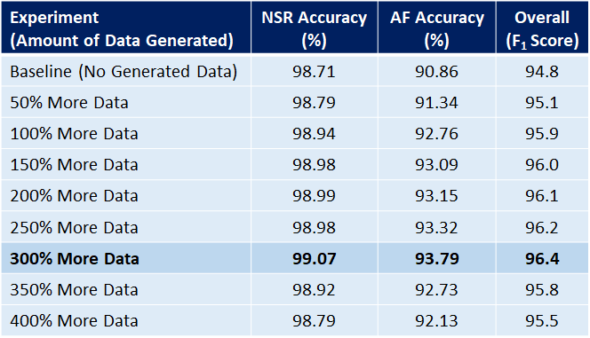

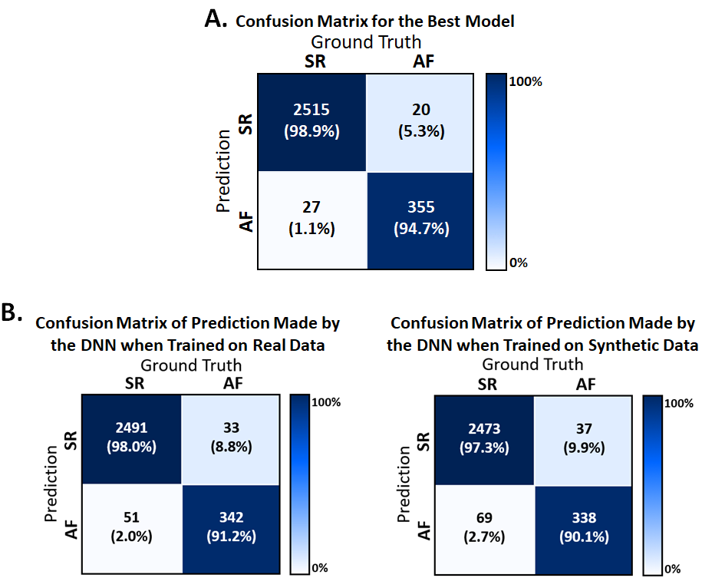
Fig. 11. Evaluation results for the detection of sinus rhythm (SR) and atrial fibrillation (AF). A) The confusion matrix of the best performing algorithm for error analysis and diagnostics. Columns represent the expert annotations and rows represent the prediction made by the deep learning algorithm. The color map is normalized between 0% and 100%. B) Confusion matrix when evaluating the testing set predictions of our proposed convolutional recurrent network (CRN) trained on only clinically recorded ECGs and trained on only synthetic ECGs.

Error analysis via a confusion matrix revealed the greatest proportion of error was due to the mislabeling of SR ECGs as AF (Fig. 11A). To analyze the discrepancies between the CRN predictions and expert ground truth annotations, ECGs incorrectly predicted by the CRN were visualized. Fig. 12A contains two samples of SR predicted as AF, containing substantial noise blurring the morphology of the P-QRS-T waveforms. The presence of an inconsistent R-peak causing an inconsistent heart rate in SR also contributed to the difficulty in classifying the ECG. Fig. 12B contains a sample of AF predicted as SR. The signal contained a fairly consistent heart rate throughout the entire recording apart from small segments which had minor varying RR intervals, potentially being difficult to detect by the CRN.

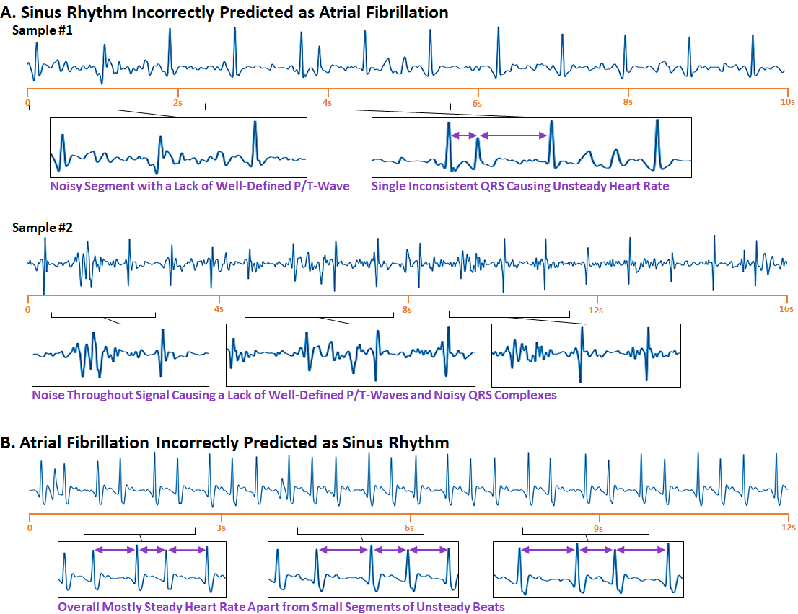
Fig. 12. Visualization of electrocardiograms (ECG) incorrectly classified by the deep learning algorithm. A) Samples of normal sinus rhythm (SR) ECGs mistakenly classified as atrial fibrillation (AF). The enlarged regions with a high degree of noise and irregular R-peak-to-R-peak (RR) intervals may contribute to an erroneous prediction. B) A sample of AF ECG mistakenly classified as SR. The overall regularity of the heart rate creates difficulties in detecting the small segments of irregular RR intervals (enlarged regions).

Discussion
Analysis of ECGs for the detection of AF is a challenging task due to the high variability, complexity, and various noise present in ECGs. Our study presents a CRN capable of classifying ECG signals into SR and AF with an accuracy of 96.4%. Furthermore, we have proposed a method of generating realistic synthetic ECGs to aid CRN training, and showed the subsequent improvement in the accuracy of AF detection by 3%. More importantly, our algorithm successfully identified 94.7% of ECGs with AF occurrences while minimizing false alerts to around 1%. By embedding our approach into a mobile application, we believe our approach may potentially be a more efficient method for monitoring patients with AF, enabling earlier detection and prevention of the serious complications of AF.

Methods of AF Detection
The lack of portability and accessibility of the most widely used 12-lead recording device has led to the development of more efficient, self-monitoring mobile devices [27, 28]. In recent years, the most popular mobile technologies for AF detection are based on either the PPG or the ECG approaches [8, 10, 29]. However, despite the advantages of automated patient-monitoring, these devices suffer from a lack of patient samples, particularly, AF patients in the trial cohorts. A recent study utilizing the Apple Watch for ECG classification confirmed only around 150 cases of AF from a study cohort of over 400,000 patients [8]. The low prevalence of AF in these cohorts, therefore, is a major limiting factor when considering the development of intelligent algorithms such as CRNs for more accurate AF detection.
Our study aimed to solve this issue with a novel method of ECG generation to provide our CRN with a large number of samples for effective training. By applying our approach, we artificially increased our current sample of 383 AF training cases to over 1,500 which is significantly more than the aforementioned studies.

Deep Learning for ECG Classification
The CRN proposed in this study achieved accuracies for AF detection exceeding most current large-scale studies involving commercially developed ECG and PPG smart devices. While direct comparisons are difficult due to varying study designs and methods, we show that our approach achieved a 93.8% accuracy. This was an improvement compared to the 91.7% achieved by Valiaho et al. [29] and 91.7% achieved by Guo et al. using the Huawei Watch [10]. Our results were also competitive with that of Bumgarner et al., who reported a 93% accuracy using the ECGs recorded from the Kardia Band [9].
The ability of the proposed CRN to directly learn from raw ECG signals was another advantage. While it has been shown that the structural changes caused by AF are likely to lead to changes in the P-QRS-T formation [30], clinical studies on AF patients with regional non-sinus contractions of the left atrial appendage occasionally display apparent SR on ECG recording [31, 32]. This occurrence may be explained by the fact that regional non-sinus electrical activities are actually reflected through waveform features smaller than readily observable P-waves. By training a CRN on sufficient clinical ECG samples, subtle features not typically considered by trained professionals may be implicitly learned and result in a more robust framework.

Limitations and Future Work
A limitation of this study was the small sample size of the clinical ECG dataset. While the sample of approximately 6,000 ECG recordings is currently, to our knowledge, one of the largest publicly accessible datasets available, it is still incredibly small compared to today’s standards of deep learning [20]. Larger datasets would also be beneficial for performing more extensive validation by partitioning the dataset into additional testing sets which were independent from the data used for parameter selection during model development. Although our study aimed to tackle this problem through synthetic data generation, it is only possible for the generated data to contain features already present in the clinical ECGs. While results showed an improvement in the AF detection accuracy, the availability of more data samples may result in higher performances. This would be particularly beneficial for evaluating generalizability and optimality of the proposed network and amount of synthetic data generated. Furthermore, since the generator exploits features in existing clinical ECGs, the generated data may contain flaws that are inherently present, such as the presence of excessive noise or signals which lack sufficient features to be classified accurately.
In the future, we hope to develop more robust methods of AF detection from ECGs by utilizing more advanced CRNs, and potentially expand our approach to detect other types of rhythm disturbances. By validating our approach on a larger clinical dataset, we may further improve the performance of our algorithms as well as explore opportunities and applications for data synthesis.

Conclusion
In this study, we have developed and validated a CRN on an open dataset for the detection of AF from single-lead ECGs. The CRN achieved an accuracy of 96.4% when validated on clinical ECG recordings and our novel method for synthetic ECG generation resulted in a 3% improvement in the accuracy of AF detection. For the clinical prospect, by embedding our approach into a mobile device, the proposed framework could aid AF diagnosis and be used for patient self-monitoring to improve the early detection of AF. Potentially, improved AF detection could lead to effective treatment and monitoring of patients suffering AF worldwide.
Acknowledgment
We are grateful for NVidia for donating a Titan-V GPU for our algorithm development and testing and would like to acknowledge the Health Research Council of New Zealand and the Heart Foundation New Zealand for funding this research. We would also like to thank PhysioNet for providing the open-source ECG dataset.
References
[1] G. Y. H. Lip, L. Fauchier, S. B. Freedman, I. Van Gelder, A. Natale, C. Gianni, et al., "Atrial fibrillation," Nature Reviews Disease Primers, vol. 2, p. 16016, 03/31/online 2016.
[2] S. M. Narayan, M. Rodrigo, C. A. Kowalewski, F. Shenasa, G. L. Meckler, M. N. Vishwanathan, et al., "Ablation of Focal Impulses and Rotational Sources: What Can Be Learned from Differing Procedural Outcomes?," Current Cardiovascular Risk Reports, vol. 11, p. 27, 2017.
[3] J. Zhao, B. J. Hansen, Y. Wang, T. A. Csepe, L. V. Sul, A. Tang, et al., "Three‐dimensional Integrated Functional, Structural, and Computational Mapping to Define the Structural “Fingerprints” of Heart‐Specific Atrial Fibrillation Drivers in Human Heart Ex Vivo," Journal of the American Heart Association, vol. 6, p. e005922, 2017.
[4] H. Pürerfellner, E. Pokushalov, S. Sarkar, J. Koehler, R. Zhou, L. Urban, et al., "P-wave evidence as a method for improving algorithm to detect atrial fibrillation in insertable cardiac monitors," Heart Rhythm, vol. 11, pp. 1575-1583, 2014.
[5] M. García, J. Ródenas, R. Alcaraz, and J. J. Rieta, "Application of the relative wavelet energy to heart rate independent detection of atrial fibrillation," computer methods and programs in biomedicine, vol. 131, pp. 157-168, 2016.
[6] K. Tateno and L. Glass, "Automatic detection of atrial fibrillation using the coefficient of variation and density histograms of RR and ΔRR intervals," Medical and Biological Engineering and Computing, vol. 39, pp. 664-671, 2001.
[7] M. Carrara, L. Carozzi, T. J. Moss, M. de Pasquale, S. Cerutti, M. Ferrario, et al., "Heart rate dynamics distinguish among atrial fibrillation, normal sinus rhythm and sinus rhythm with frequent ectopy," Physiological measurement, vol. 36, p. 1873, 2015.
[8] M. V. Perez, K. W. Mahaffey, H. Hedlin, J. S. Rumsfeld, A. Garcia, T. Ferris, et al., "Large-Scale Assessment of a Smartwatch to Identify Atrial Fibrillation," New England Journal of Medicine, vol. 381, pp. 1909-1917, 2019.
[9] J. M. Bumgarner, C. T. Lambert, A. A. Hussein, D. J. Cantillon, B. Baranowski, K. Wolski, et al., "Smartwatch algorithm for automated detection of atrial fibrillation," Journal of the American College of Cardiology, vol. 71, pp. 2381-2388, 2018.
[10] Y. Guo, H. Wang, H. Zhang, T. Liu, Z. Liang, Y. Xia, et al., "Mobile photoplethysmographic technology to detect atrial fibrillation," Journal of the American College of Cardiology, vol. 74, pp. 2365-2375, 2019.
[11] B. P. Yan, W. H. Lai, C. K. Chan, S. C. H. Chan, L. H. Chan, K. M. Lam, et al., "Contact‐Free Screening of Atrial Fibrillation by a Smartphone Using Facial Pulsatile Photoplethysmographic Signals," Journal of the American Heart Association, vol. 7, p. e008585, 2018.
[12] Z. Xiong, V. V. Fedorov, X. Fu, E. Cheng, R. Macleod, and J. Zhao, "Fully automatic left atrium segmentation from late gadolinium enhanced magnetic resonance imaging using a dual fully convolutional neural network," IEEE transactions on medical imaging, vol. 38, pp. 515-524, 2018.
[13] O. Ronneberger, P. Fischer, and T. Brox, "U-net: Convolutional networks for biomedical image segmentation," in International Conference on Medical image computing and computer-assisted intervention, 2015, pp. 234-241.
[14] G. D. Clifford, C. Liu, B. Moody, H. L. Li-wei, I. Silva, Q. Li, et al., "AF Classification from a short single lead ECG recording: the PhysioNet/Computing in Cardiology Challenge 2017," in 2017 Computing in Cardiology (CinC), 2017, pp. 1-4.
[15] O. Sayadi, M. B. Shamsollahi, and G. D. Clifford, "Robust detection of premature ventricular contractions using a wave-based Bayesian framework," IEEE Transactions on Biomedical Engineering, vol. 57, pp. 353-362, 2009.
[16] L. A. Gatys, A. S. Ecker, and M. Bethge, "Image style transfer using convolutional neural networks," in Proceedings of the IEEE conference on computer vision and pattern recognition, 2016, pp. 2414-2423.
[17] D. P. Kingma and J. Ba, "Adam: A method for stochastic optimization," arXiv preprint arXiv:1412.6980, 2014.
[18] Z. Xiong, M. P. Nash, E. Cheng, V. V. Fedorov, M. K. Stiles, and J. Zhao, "ECG signal classification for the detection of cardiac arrhythmias using a convolutional recurrent neural network," Physiological measurement, vol. 39, p. 094006, 2018.
[19] Z. Xiong, M. K. Stiles, and J. Zhao, "Robust ECG signal classification for detection of atrial fibrillation using a novel neural network," in 2017 Computing in Cardiology (CinC), 2017, pp. 1-4.
[20] K. He, X. Zhang, S. Ren, and J. Sun, "Deep residual learning for image recognition," in Proceedings of the IEEE conference on computer vision and pattern recognition, 2016, pp. 770-778.
[21] S. Ioffe and C. Szegedy, "Batch normalization: Accelerating deep network training by reducing internal covariate shift," arXiv preprint arXiv:1502.03167, 2015.
[22] G. E. Dahl, T. N. Sainath, and G. E. Hinton, "Improving deep neural networks for LVCSR using rectified linear units and dropout," in 2013 IEEE international conference on acoustics, speech and signal processing, 2013, pp. 8609-8613.
[23] N. Srivastava, G. Hinton, A. Krizhevsky, I. Sutskever, and R. Salakhutdinov, "Dropout: a simple way to prevent neural networks from overfitting," The journal of machine learning research, vol. 15, pp. 1929-1958, 2014.
[24] H. Sak, A. Senior, and F. Beaufays, "Long short-term memory recurrent neural network architectures for large scale acoustic modeling," in Fifteenth annual conference of the international speech communication association, 2014.
[25] M. Abadi, P. Barham, J. Chen, Z. Chen, A. Davis, J. Dean, et al., "Tensorflow: A system for large-scale machine learning," in 12th {USENIX} Symposium on Operating Systems Design and Implementation ({OSDI} 16), 2016, pp. 265-283.
[26] M. Zihlmann, D. Perekrestenko, and M. Tschannen, "Convolutional recurrent neural networks for electrocardiogram classification," in 2017 Computing in Cardiology (CinC), 2017, pp. 1-4.
[27] M. V. McConnell, M. P. Turakhia, R. A. Harrington, A. C. King, and E. A. Ashley, "Mobile health advances in physical activity, fitness, and atrial fibrillation: moving hearts," Journal of the American College of Cardiology, vol. 71, pp. 2691-2701, 2018.
[28] A. N. Koshy, J. K. Sajeev, N. Nerlekar, A. J. Brown, K. Rajakariar, M. Zureik, et al., "Smart watches for heart rate assessment in atrial arrhythmias," International journal of cardiology, vol. 266, pp. 124-127, 2018.
[29] E.-S. Väliaho, P. Kuoppa, J. Lipponen, T. Martikainen, H. Jäntti, T. Rissanen, et al., "Wrist band photoplethysmography in detection of individual pulses in atrial fibrillation and algorithm-based detection of atrial fibrillation," EP Europace, 2019.
[30] M. Haissaguerre, P. Jaïs, D. C. Shah, A. Takahashi, M. Hocini, G. Quiniou, et al., "Spontaneous initiation of atrial fibrillation by ectopic beats originating in the pulmonary veins," New England Journal of Medicine, vol. 339, pp. 659-666, 1998.
[31] K. Harjai, S. Mobarek, F. Abi-Samra, Y. Gilliland, N. Davison, K. Drake, et al., "Mechanical dysfunction of the left atrium and the left atrial appendage following cardioversion of atrial fibrillation and its relation to total electrical energy used for cardioversion," The American journal of cardiology, vol. 81, pp. 1125-1129, 1998.
[32] Z. I. Attia, P. A. Noseworthy, F. Lopez-Jimenez, S. J. Asirvatham, A. J. Deshmukh, B. J. Gersh, et al., "An artificial intelligence-enabled ECG algorithm for the identification of patients with atrial fibrillation during sinus rhythm: a retrospective analysis of outcome prediction," The Lancet, vol. 394, pp. 861-867, 2019.

 Manuscript received August 31, 2021. This work was supported by Health Research Council of New Zealand (J. Zhao) and Heart Foundation New Zealand (Z. Xiong). Asterisk indicates corresponding author. Z. Xiong and *J. Zhao are with Auckland Bioengineering Institute, The University of Auckland, Auckland, New Zealand (e-mail: j.zhao@auckland.ac.nz , Private Bag 92019, Auckland 1142, New Zealand). A. Gillis is with Department of Cardiac Sciences, Libin Cardiovascular Institute of Alberta, University of Calgary, Alberta, Canada. M. Stiles is with Waikato Clinical School, Faculty of Medical and Health Sciences, The University of Auckland, Auckland, New Zealand.

